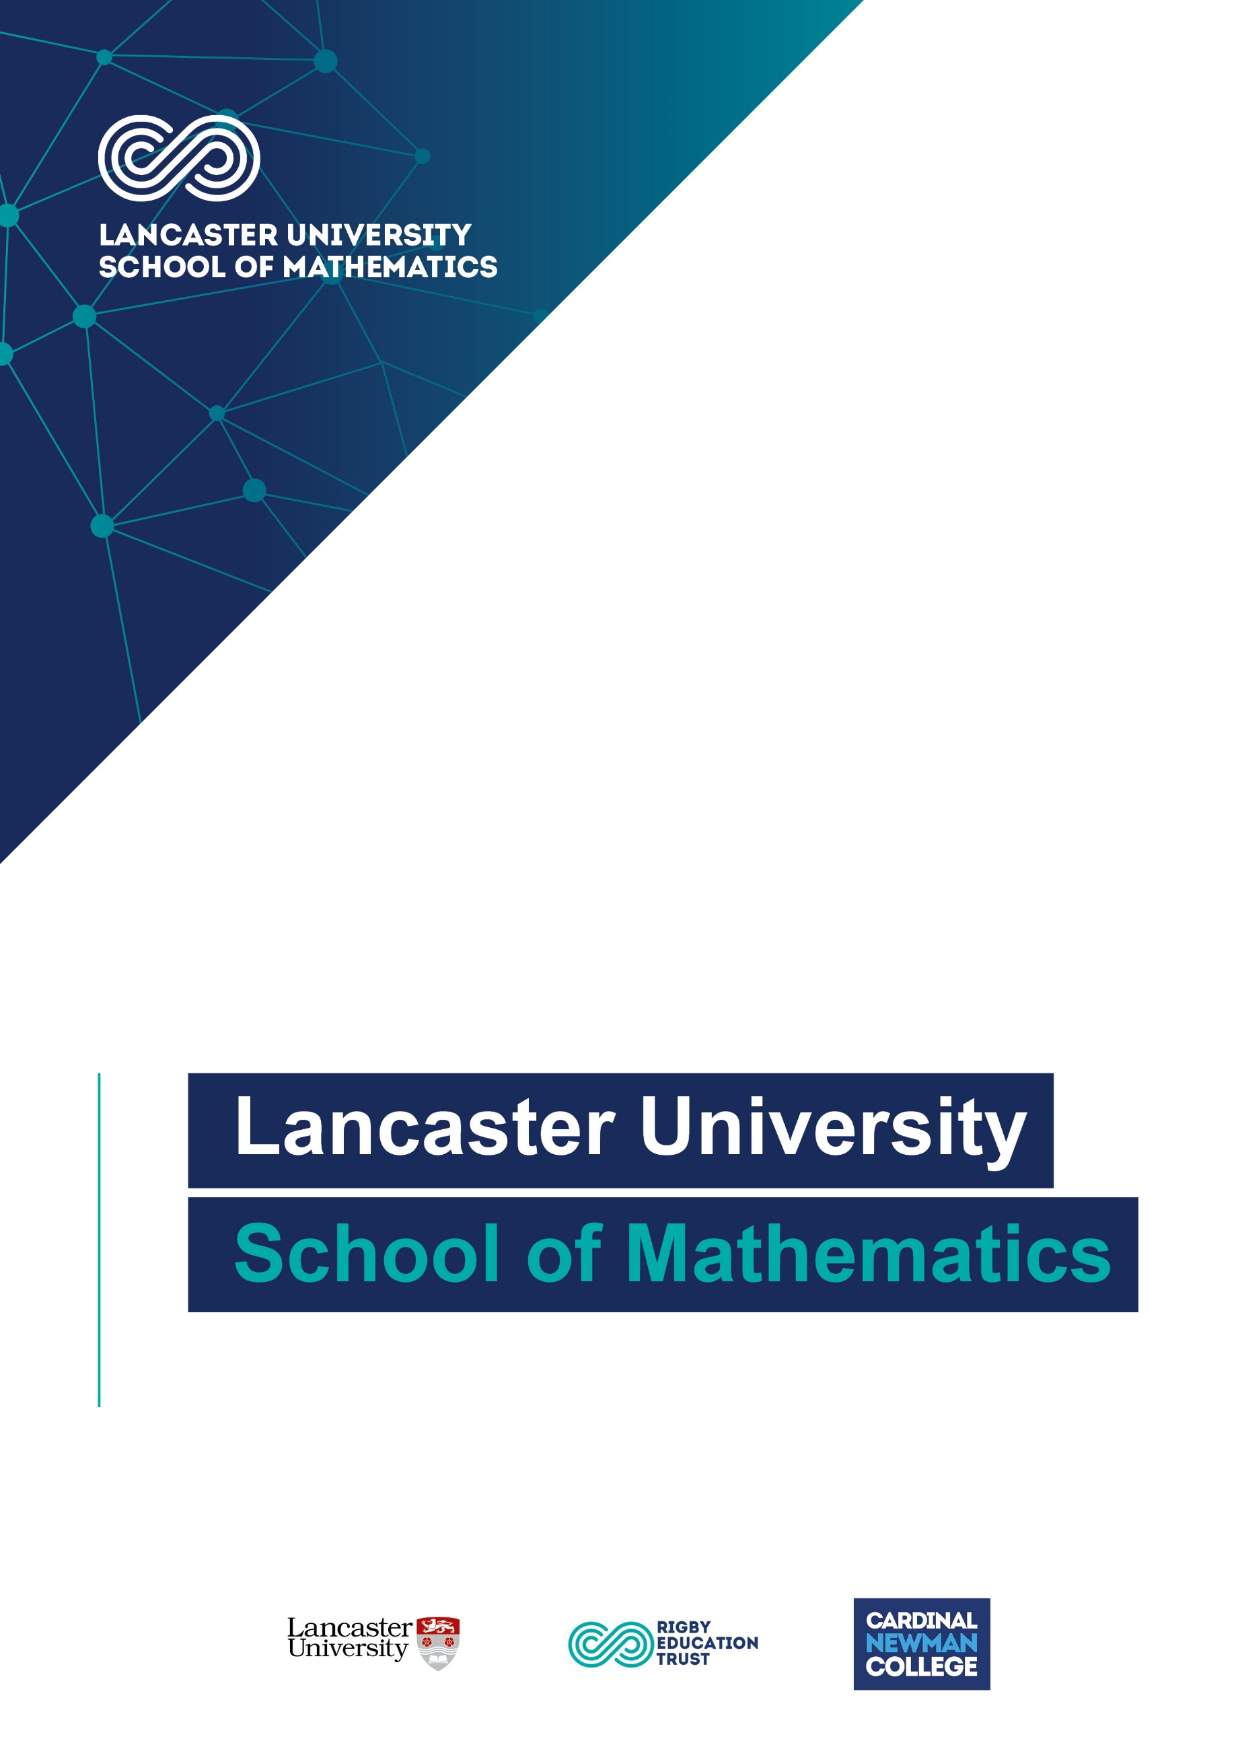
Enquiries and Internal Appeals Procedure
Owner | Head Teacher as Head of Centre
Reviewer | Exams Manager

Issue Date | October 2024
Review Date | October 2025

Applies To
All external examinations and assessments for Lancaster University School of Mathematics (LUSoM).

Purpose
This procedure confirms Lancaster University School of Mathematics (LUSoM)’s compliance with JCQ’s General Regulations for Approved Centres (section 5.3x) that the centre will:
- Have in place and available for inspection a written internal appeals procedure which must cover at least appeals regarding internal assessment decisions, post-result services and appeals, and centre decisions relating to access arrangements and special consideration
This procedure covers appeals relating to:
- Internal assessment decisions (centre assessed marks)
- Centre decisions not to support a clerical re-check, a review of marking, a review of moderation or an appeal
- Centre decisions relating to access arrangements and special consideration
- Centre decisions relating to other administrative issues

Overview
Lancaster University School of Mathematics (LUSoM) is committed to ensuring that wherever subject teachers assess students’ work for external qualifications, it is done fairly, consistently and in accordance with the specification for the qualification concerned.

Lancaster University School of Mathematics (LUSoM) is committed to ensuring that wherever exam access arrangement assessments take place, it is done fairly, consistently and in accordance with the regulations concerned.

Assessments will be conducted by employees who have appropriate knowledge, understanding and skills, and who also have the qualified experience to administer this task.

Students’ work should be produced and authenticated in accordance with the requirements of the awarding body. Where a set of work is divided between staff members, consistency will be assured by internal moderation and standardisation.

This procedure is informed by the JCQ publications A guide to the awarding bodies’ appeals processes (section 3), Suspected Malpractice: Policies and Procedures (section 3.3), General Regulations for Approved Centres (section 5.4), Access Arrangements and Reasonable Adjustments (Importance of these regulations) and A guide to the special consideration process (sections 1, 2, 6).

Appeals relating to internal assessment decisions (centre assessed marks)
Certain GCSE, GCE and other qualifications contain components of non-examination assessment (or units of coursework) which are internally assessed (marked) by Lancaster University School of Mathematics (LUSOM) and internally standardised. The marks awarded (the internal assessment decisions) which contribute to the final grade of the qualification are then submitted by the deadline set by the awarding body for external moderation.

This procedure confirms Lancaster University School of Mathematics (LUSOM)’s compliance with JCQ’s General Regulations for Approved Centres (section 5.7) that the centre will:
- have in place and be available for inspection purposes, a written internal appeals procedure relating to internal assessment decisions and to ensure that details of this procedure are communicated, made widely available and accessible to all candidates
- before submitting marks to the awarding body inform candidates of their centre assessed marks and allow a candidate to request a review of the centre’s marking

Lancaster University School of Mathematics (LUSOM) is committed to ensuring that whenever its staff mark candidates’ work this is done fairly, consistently and in accordance with the awarding body’s specification and subject-specific associated documents.

Lancaster University School of Mathematics (LUSOM) ensures that all centre staff follow a robust Non-examination Assessment Policy (for the management of GCE and GCSE non-examination assessments). This policy details all procedures relating to non-examination assessments for GCE, GCSE, Project qualifications, BTEC and T-Level.

Candidates’ work will be marked by staff who have appropriate knowledge, understanding and skill, and who have been trained in this activity. Lancaster University School of Mathematics (LUSOM) is committed to ensuring that work produced by candidates is authenticated in line with the requirements of the awarding body. Where more than one subject teacher/tutor is involved in marking candidates’ work, internal moderation and standardisation will ensure consistency of marking.

On being informed of their centre assessed marks, if a candidate believes that the above procedures were not followed in relation to the marking of his/her work, or that the assessor has not properly applied the marking standards to his/her marking, then he/she may make use of the appeals procedure below to consider whether to request a review of the centre’s marking.

Lancaster University School of Mathematics (LUSOM) will:
- Ensure that candidates are informed of their centre assessed marks so that they may request a review of the centre’s marking before marks are submitted to the awarding body.
- Inform candidates that they will need to explain on what grounds they wish to request a review of an internally assessed mark as a review will only focus on the quality of their work in meeting the published assessment criteria.
- Inform candidates that they may request copies of materials (generally as a minimum, a copy of the marked assessment material (work) and the mark scheme or assessment criteria plus additional materials which may vary from subject to subject) within 2 working days of being informed of their internally assessed marks to assist them in considering whether to request a review of the centre’s marking of the assessment.
- Having received a request for copies of materials, promptly make them available to the candidate (or for some marked assessment materials, such as art work and recordings, inform the candidate that the originals will be shared under supervised conditions) within 3 working days.
- Inform candidates they will not be allowed access to original assessment material unless supervised.
- Provide candidates with sufficient time in order to allow them to review copies of materials and reach a decision, informing candidates that if their decision is to request a review, they will need to explain what they believe the issue to be.
- Provide a clear deadline for candidates to submit a request for a review of the centre’s marking. Requests will not be accepted after this deadline. Requests must be made in writing within 5 working days of receiving copies of the requested materials (or within 10 working days of being informed of internally assessed marks if no copies of work have been requested) by completing the form for an Internal Assessment Appeal Request Form (available in the Exam Information section of the school website) and returning to the Exams Office via email to lusomexams@lusom.ac.uk or in hard copy to T007.
- Allow 5 working days for the review to be carried out, to make any necessary changes to marks and to inform the candidate of the outcome, all before the awarding body’s deadline for the submission of marks.
- Ensure that the review of marking is conducted by an assessor who has appropriate competence, has had no previous involvement in the assessment of that candidate for the component in question and has no personal interest in the outcome of the review.
- Instruct the reviewer to ensure that the candidate’s mark is consistent with the standard set by the centre.
- Inform the candidate in writing of the outcome of the review of the centre’s marking.

The awarding body will be informed if the centre does not accept the outcome of a review.

The moderation process carried out by the awarding bodies may result in a mark change, either upwards or downwards, even after an internal review. The internal review process is in place to ensure consistency of marking within the centre, whereas moderation by the awarding body ensures that centre marking is in line with national standards. The mark submitted to the awarding body is subject to change and should therefore be considered provisional.

Appeals relating to centre decisions not to support a clerical re-check, a review of marking, a review of moderation or an appeal
This procedure confirms Lancaster University School of Mathematics (LUSOM)’s compliance with JCQ’s General Regulations for Approved Centres (section 5.13) that the centre will:
- have available for inspection purposes and draw to the attention of candidates and their parents/carers, a written internal appeals procedure to manage disputes when a candidate disagrees with a centre decision not to support an online application for a clerical re-check, a review of marking, a review of moderation or an appeal.

Following the issue of results, awarding bodies make post-results services available. Full details of these services, internal deadlines for requesting a service and fees charged are published in the Exam Information Section of the School website, and students are directed to this in the email sent out prior to Results Day.

Candidates are also informed of the periods during which senior members of centre staff will be available/accessible immediately after the publication of results so that results may be discussed, and decisions made on the submission of reviews of marking. Candidates are informed of this via email before results are published.

If the centre or a candidate has a concern and believes a result may not be accurate, post-results services may be considered.

The JCQ post-results services currently available are detailed below.

Reviews of Results (RoRs):
- Service 1 (Clerical re-check)
This is the only service that can be requested for objective tests (multiple choice tests)
- Service 2 (Review of marking)
- Priority Service 2 (Review of marking)
This service is only available for externally assessed components of GCE A-level specifications (an individual awarding body may also offer this priority service for other qualifications)
- Service 3 (Review of moderation)
This service is not available to an individual candidate

Access to Scripts (ATS):
- Copies of scripts to support reviews of marking
- Copies of scripts to support teaching and learning

Where a concern is expressed that a particular result may not be accurate, the centre will look at the marks awarded for each component part of the qualification alongside any mark schemes, relevant result reports, grade boundary information etc. when made available by the awarding body to determine if the centre supports any concerns.

Where a student’s overall marks for a qualification are 3 or less marks away from the upper grade boundary for the qualification, the centre will consider the following for written components that contributed to the final result:
- Where a place a university or college is at risk, consider supporting a request for a Priority Service 2 review of marking.
- In all other instances, consider accessing the script by:
- (where the service is made available by the awarding body) requesting a priority copy of the candidate’s script to support a review of marking by the awarding body deadline or
- (where the option is made available by the awarding body) viewing the candidate’s marked script online to consider if requesting a review of marking is appropriate
- Collect informed written consent/permission from the candidate to access his/her script
- On access to the script, consider if it is felt that the agreed mark scheme has been applied correctly in the original marking and if the centre considers there are any errors in the marking
- Support a request for the appropriate RoR service (clerical re-check or review of marking) if any error is identified
- Collect informed written consent from the candidate to request the RoR service before the request is submitted
- Where relevant, advise an affected candidate to inform any third party (such as a university or college) that a review of marking has been submitted to an awarding body]

Written candidate consent is required in all cases before a request for a RoR service 1 or 2 (including priority service 2) is submitted to the awarding body. Consent is required to confirm the candidate understands that the final subject grade and/or mark awarded following a clerical re-check or a review of marking, and any subsequent appeal, may be lower than, higher than, or the same as the result which was originally awarded. Candidate consent must only be collected after the publication of results.

For any moderated components that contributed to the final result, the centre will:
- Confirm that a review of moderation cannot be undertaken on the work of an individual candidate or the work of candidates not in the original sample submitted for moderation
- Consult the moderator’s report/feedback to identify any issues raised
- Determine if the centre’s internally assessed marks have been accepted without change by the awarding body – if this is the case, a RoR service 3 (Review of moderation) will not be available
- Determine if there are any grounds to submit a request for a review of moderation for the work of all candidates in the original sample

Where a candidate disagrees with a centre decision not to support a clerical re-check, a review of marking or a review of moderation, the centre will submit a request for post results services upon completion of the relevant consent form and payment of the associated fees, as detailed in our Post Results Services Information document, published in the Exam Information section of the School website.

If the candidate believes there are grounds to appeal against the centre’s decision not to support a review of results, an internal appeal can be submitted to the centre by emailing lusomexams@lusom.ac.uk at least 7 calendar days prior to the internal deadline for submitting a request for a review of results.

The appellant will be informed of the outcome of his/her appeal before the internal deadline for submitting a request for a review of results.

Following the RoR outcome, an external appeals process is available if the head of centre remains dissatisfied with the outcome and believes there are grounds for appeal. The JCQ publications Post-Results Services and JCQ Appeals Booklet (A guide to the awarding bodies’ appeals processes) will be consulted to determine the acceptable grounds for a preliminary appeal.

Where the head of centre is satisfied after receiving the RoR outcome, but the candidate believes there are grounds for a preliminary appeal to the awarding body, a further internal appeal may be made to the head of centre. Following this, the head of centre’s decision as to whether to proceed with a preliminary appeal will be based upon the acceptable grounds as detailed in the JCQ Appeals Booklet. Candidates or parents/carers are not permitted to make direct representations to an awarding body.

An email should be sent to lusomexams@lusom.ac.uk requesting an appeal against a review of results outcome, within 15 calendar days of the notification of the outcome from the awarding body. Subject to the head of centre’s decision, this will allow the centre to process the preliminary appeal and submit to the awarding body within the required 30 calendar days of the awarding body issuing the outcome of the review of results process. Awarding body fees which may be charged for the preliminary appeal must be paid to the centre by the appellant before the preliminary appeal is submitted to the awarding body (fees are available from the Exams Department). If the appeal is upheld by the awarding body, this fee will be refunded by the awarding body and repaid to the appellant by the centre.

Appeals regarding centre decisions relating to access arrangements and special consideration
This procedure confirms Lancaster University School of Mathematics (LUSOM)’s compliance with JCQ’s General Regulations for Approved Centres (section 5.3x) that the centre will:
- have in place and available for inspection a written internal appeals procedure which must cover at least appeals regarding... centre decisions relating to access arrangements and special consideration

Lancaster University School of Mathematics (LUSOM)will:
- comply with the principles and regulations governing access arrangements and special consideration as set out in the JCQ publications Access Arrangements and Reasonable Adjustments and A guide to the special consideration process
- ensure that all staff who manage and implement access arrangements and special consideration are aware of the requirements and are appropriately supported and resourced

Access arrangements and reasonable adjustments
In accordance with the regulations, Lancaster University School of Mathematics (LUSOM) will:
- recognises its duty to explore and provide access to suitable courses, through the access arrangements process submit applications for reasonable adjustments and make reasonable adjustments to the service the centre provides to disabled candidates.
- complies with its responsibilities in identifying, determining and implementing appropriate access arrangements and reasonable adjustments

Failure to comply with the regulations have the potential to constitute malpractice which may impact on a candidate’s result(s). Examples of failure to comply include:
- putting in place access arrangements/adjustments that are not approved
- failing to consider putting in place access arrangements (which may be a failure to comply with the duty to make reasonable adjustments)
- permitting access arrangements/adjustments within the centre which are not supported by appropriate evidence
- charging a fee for providing reasonable adjustments to disabled candidates AARA (Importance of these regulations)

Special consideration
Where Lancaster University School of Mathematics (LUSOM) can provide signed evidence to support an application, it will apply for special consideration at the time of the assessment for a candidate who has temporarily experienced illness, injury or some other event outside of their control when the issue or event has had, or is reasonably likely to have had, a material effect on the candidate’s ability to take an assessment or demonstrate his or her normal level of attainment in an assessment.

Centre decisions relating to access arrangements, reasonable adjustments and special consideration
This may include Lancaster University School of Mathematics (LUSOM)’s decision not to make/apply for a specific reasonable adjustment or to apply for special consideration, in circumstances where a candidate does not meet the criteria for, or there is no evidence/insufficient evidence to support the implementation of an access arrangement/reasonable adjustment or the application of special consideration.

Where Lancaster University School of Mathematics (LUSOM) makes a decision in relation to the access arrangement(s), reasonable adjustment(s) or special consideration that apply for a candidate or candidates:
- If a candidate who is the subject of the relevant decision disagrees with the decision made and reasonably believes that the centre has not complied with its responsibilities or followed due procedures, a written request setting out the grounds for appeal should be submitted by email to exams@lusom.ac.uk within 5 working days of the decision being made known to the appellant.

To determine the outcome of the appeal, a member of the senior leadership team not involved in the original decision will consult the respective JCQ publication to confirm the centre has complied with the principles and regulations governing access arrangements and/or special consideration and followed due procedures.

The appellant will be informed of the outcome of the appeal within 5 working days of the appeal being received and logged by the centre.

If the appeal is upheld, Lancaster University School of Mathematics (LUSOM) will proceed to implement the necessary arrangements/submit the necessary application.

Appeals regarding centre decisions relating to other administrative issues
Circumstances may arise that cause Lancaster University School of Mathematics (LUSOM) to make decisions on administrative issues that may affect a candidate’s examinations/assessments.

Where Lancaster University School of Mathematics (LUSOM) may make a decision that affects a candidate or candidates:
- If a candidate who is the subject of the relevant decision (or the candidate’s parent/carer) disagrees with the decision made and reasonably believes that the centre has not complied with the regulations or followed due process, a written request setting out the grounds for appeal should be submitted by email to exams@lusom.ac.uk within 5 working days of the decision being made known to the appellant

The appellant will be informed of the outcome of the appeal within 5 working days of the appeal being received and logged by the centre.

Monitoring
These procedures are reviewed and updated annually, or where required by regulation, to ensure that Lancaster University School of Mathematics (LUSOM) operates in accordance with current requirements and regulations.

